|  |  |
| --- | --- |
|  | **Sri Sivasubramaniya Nadar College of Engineering, Kalavakkam – 603 110**  **(An Autonomous Institution, Affiliated to Anna University, Chennai)**  Computer Science and Engineering |

|  |  |  |  |  |  |  |  |
| --- | --- | --- | --- | --- | --- | --- | --- |
| Course Code | **UCS2601** | Course Name | Internet Programming | | | | |
| Course Type | **Theory** | Course Category | Professional Core (PC) | **L** | **T** | **P** | **C** |
| **3** | **0** | **0** | **3** |
| Regulation | **R-2021** | | Academic Year | **2024-25 (Even)** | | | |
| Degree and Branch | **B.E. Computer Science & Engineering** | | Batch | **2022-26** | | | |
| Semester | | **VI** | Faculty Name | **Dr. S. Raghavendra Kumar**  **Dr. B. Prabavathy**  **Dr. Rajeswari** | | | |
| Department Offering the Course | | | **Computer Science and Engineering** | | | | |

**OUTCOMES**

On successful completion of this course, the student will be able to:

1. Make use of HTML5 and CSS3 to design modern web site (K3)

2. Utilize Javascript and DOM to implement dynamic web page (K3)

3. Develop responsive web applications using Servlets and AJAX (K3)

4. Build web application using ReactJS framework (K3)

5. Develop web application using NodeJS framework (K3)

**CAT1 – Assignment**

**Design Phase of *InternTrack* Full Stack Web Application**

Students gain practical experience by doing internship in industries. It bridges the gap between academic knowledge and real-world applications. In the organization, there needs to be a tracking mechanism that maintains the details of the information related to internships.

Refer to the following Google Drive Link to design ***InternTrack Full Stack Web Application***:

[Internship Batch 2022-2026 - Google Drive](https://drive.google.com/drive/folders/1h27wfGTdU-C252Vy6psYNC0viER_WQjR)

The objective of ***InternTrack Full Stack Web Application*** is to have credentials for Student and Coordinator with necessary authorization and access rights.

It has the following basic functionalities:

* Load the Details with the necessary proofs
* View the list of the internship
* Retrieve the information
* Edit the details

Design the forms related to the functionalities *Load, View, Retrieve and Edit* for the whole application as follows using HTML5 and CSS3. (CO1, K6)

Keep Google Drive as your backend, come up with innovative designs that will help reduce the ambiguity.

Add responsiveness designing of elements that can be usable with any device.

Design forms and sequence them both for student and coordinator pages. A sample is shown below:

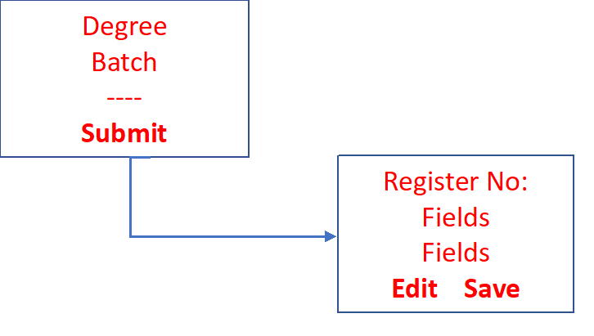

Proof for the design of your choice. For example, all necessary interactions with Google Drive. For example

* Pull data from Excel to the web page in table
* Display dynamic fields in web page
* Save the entry in Excel sheet of the Drive
* Verify the contents (Start Date, End Date, Stipend and Company) from the corresponding uploaded Internship Offer Letter (pdf) in Coordinator page

|  |
| --- |
| **Registration No: ------ 4001**  ---  ---  ---- |

|  |  |  |  |  |  |  |
| --- | --- | --- | --- | --- | --- | --- |
| Free music and multimedia icons | Backward Button - Free arrows icons | **Edit** | **Verify** | **Save** | Fast forward Button - Free controls icons | End Button Stock Illustrations – 10,973 ... |

Coordinator page also facilitate printing the following:

Refer the master list and display the response page for each of the following:

* List students batchwise
* List of students got internship through CDC
* List of students got internship not through CDC
* List of students got Academic internship
* List of students got Industry internship
* **List of students got internship in the specified Academic year**
* Given the internship period, list of students
* Company-wise list of students
* List of students who has stipend more than 1 Lakh
* List of students completed internship in Abroad
* List of students completed internship in India

A sample - Student Login Page :

